Across the Diocese
Email Newsletter of the Diocese of Olympia
August 20, 2021

https://ecww.org/locally-centered-ministries-all-saints-vancouvers-babies-in-need/

Locally Centered Ministries:

All Saints, Vancouver’s Babies in Need

We’re sharing the stories of ministries in congregations around the diocese, celebrating the incredible work being done on the local level. In this local ministry profile, Kitty Ash of All Saints, Vancouver speaks about Babies in Need.

Babies in Need serves low-income families of all racial, ethnic, educational, and religious backgrounds; premature and special needs babies; unsupported mothers; homeless women and babies; victims of domestic violence or substance abuse; and families with medical problems or job loss. We don’t ask for any proof or paperwork, just a request for help. What our neighbors receive is concrete help, love, and the gift of hope.
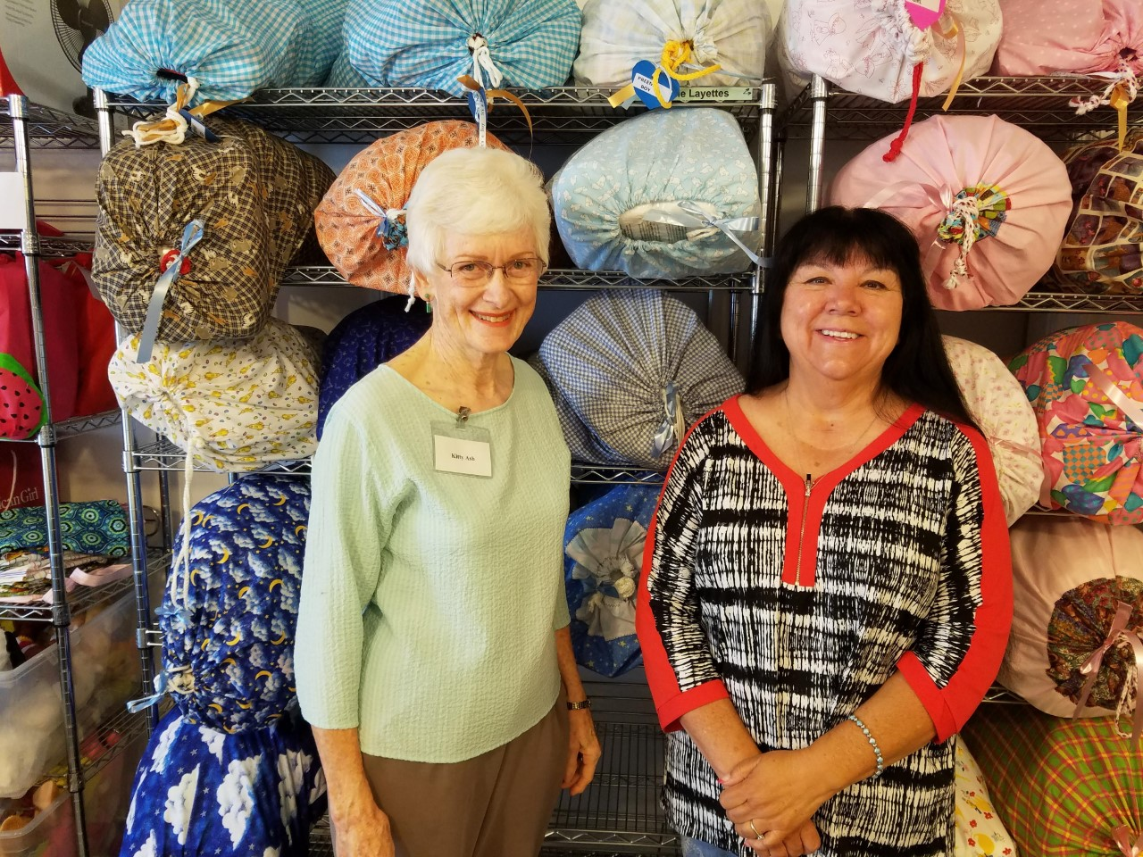
It all started when the mother of a newborn asked her hospital birth center’s social worker if she could borrow a pillowcase to take her baby home. She had nothing for her baby. The social worker, a member of All Saints, Vancouver, bought some things for the mom on her lunch hour, and the next Sunday she told us the story. We were appalled and saddened to learn that this happens routinely, so we gathered outgrown and unused baby clothes from our attics and closets, washed and sorted them into layettes and gave them to the social worker. We took up a collection for car seats and Babies in Need was born. That was in 1999. In partnership with many churches, community organizations, social groups, and loving individuals, we’ve been able to give over 5,400 layettes, 2,802 car seats, and 900 sibling bags. All God needed was a few people, a tiny congregation, to say, “Yes!” and begin. God took it from there and supplied workers, donors, guidance, and whatever was needed each step of the way. It’s been a lot like the miracle of the loaves and fishes.
We give “our babies” a large layette gift bag with all the basics for the first few months of life. It contains clothing, diapers, wipes, bath essentials, blankets, toys, and books. Important additions include To the Mother of a New Baby and A Man and a New Baby, written for Babies in Need by Mollie Smart, PhD, author and co-author of many books on child development. She writes words of guidance, encouragement, and wisdom. Walk into Prayer was written by a local team for parents of any or no faith and their babies. It is beautifully illustrated by the Rev. Elise Astleford, local priest and artist. Free Local Resources is a comprehensive list in English and Spanish.
Our brand-new car seats keep babies safe. Generous donations of equipment enable us to give larger items as well. Some examples: pack ‘n plays, bassinets, cribs, strollers, highchairs, and swings. We also give sibling bags to bring smiles to the faces of new big brothers and sisters, and let them know they are special, too!
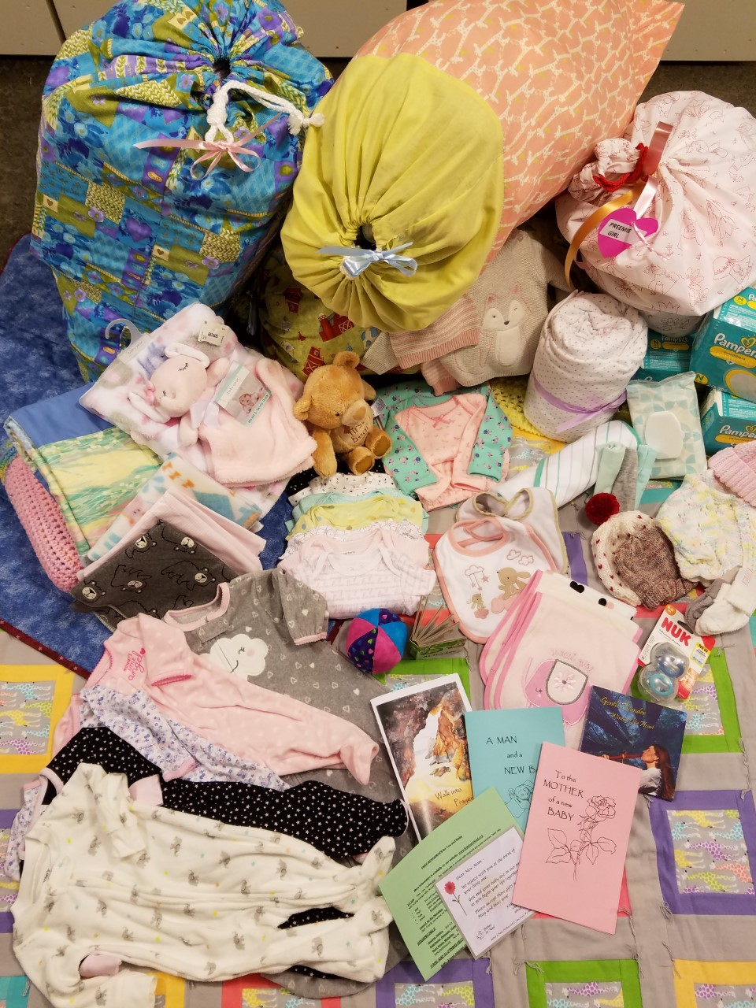
Social Workers at PeaceHealth Southwest, Legacy Salmon Creek and PeaceHealth St. John’s identify moms who need our help. We keep a supply of layettes, car seats and sibling bags in each hospital to be given any time of the day or night when needed. Community social workers contact us for help, and other moms come directly to us if they need help after discharge.
This ministry is such fun! Who doesn’t love babies? We also love playing with the beautiful donations and assembling special layettes for “our babies!” Close friendships are formed among the volunteers. Women knit and sew, groups have baby showers, Kiwanis sets up Giving Trees, beauty salons and churches maintain collection boxes, St. Luke-San Lucas prints our Walk into Prayer booklets, and businesses and social groups collect money. PeaceHealth Southwest donates our diapers. When we outgrew the available space at All Saints in 2011, First United Methodist Church, Vancouver, gave us seed money and volunteer labor to build a 20×30’ building. They supplied volunteer engineers, electricians, carpenters, roofers, and painters. Friends of the Carpenter custom-built shelving and rolling storage bins. In 2019, St. Stephen’s, Longview partnered with us to expand this ministry to serve needy families in Cowlitz County through PeaceHealth St. John’s Birth Center. More blessings all around.

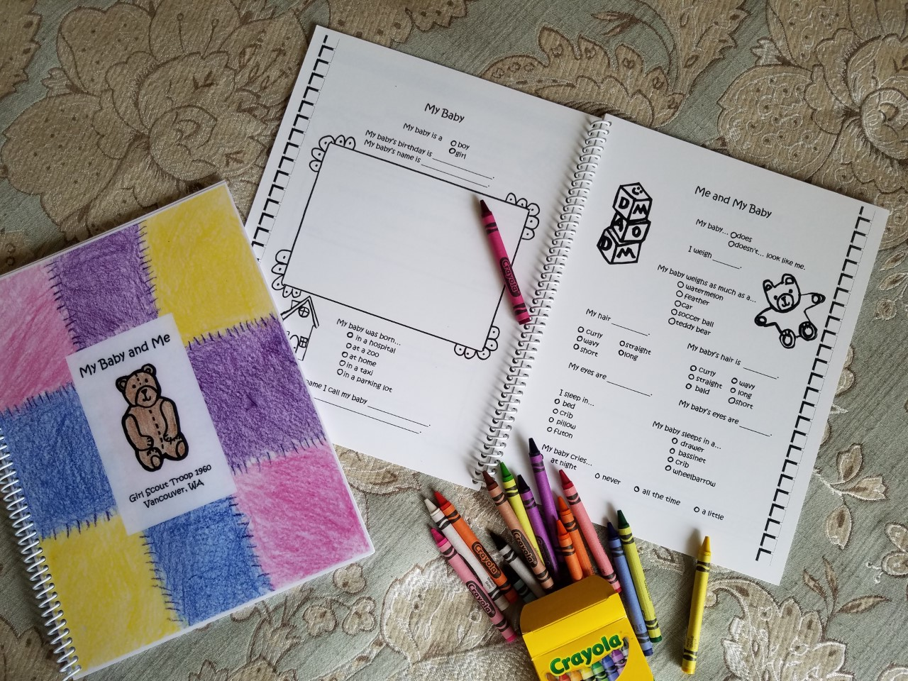
Recently, a 60-year-old grandma and disabled grandfather took in their son’s one-week-old infant. The child was born addicted. They had nothing with which to start caring for the baby and we were able to help with many things. They especially appreciated a swing that proved to be very soothing for their little one.
We assisted a teen mom who made the tough decision to place her baby for adoption. She chose a family member from out of state who drove across the United States to take the baby home. The birth mom wanted to be able to send some clothes and basic supplies with her baby and we were able to help. What a blessing that was for the birth mom, the baby, the new parents, and us!
A young family was already behind on their rent and other bills when their twin boys were born. Now they had four boys under four and so many expenses. They were overwhelmed with gratitude to receive our big, bright, cheery bags of baby clothes and supplies and two new car seats. It was such a relief to them!
The last year and a half of Covid regulations didn’t seem to affect the number of babies needing help. Clothing and hand-made donations increased. Delivery protocols at the hospitals were modified but not cumbersome. However, our volunteers really missed gathering monthly to assemble layettes! Two volunteers came in on alternate days during the week to sort donations and assemble all our layettes. Now we’re all thankful to be back to our joyful monthly assembly days.
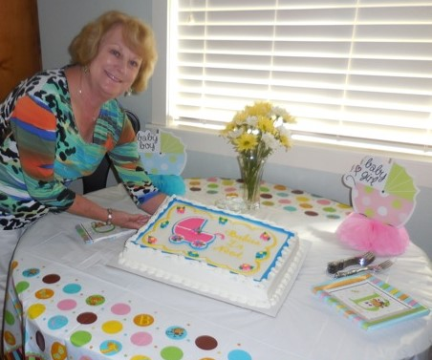
Our dream is to help other churches begin similar ministries in their communities. The need is great. Every ministry will develop differently, and we are happy to share what we’ve learned.
Most needed help? Funding for car seats which we must purchase new. Each car seat costs $96 and keeps a baby safe up to 35 pounds – about three years.
What do we want others to know? This ministry continues to grow by word of mouth. While its goal is to help the families of newborns in need, it is much broader than that, providing an outlet for those who sew, knit and crochet to give of themselves, providing community service hours for school kids and scouts, and building community among the volunteers who help sort, fill layettes, and more. We appreciate the broad support of our local community, and friends and churches in the Diocese of Olympia. It does “take a village.” We were inspired by the outreach ministries of the little church of St. James in Cathlamet. We pray that we may inspire other small churches because though we may be small, with God’s help we can do great things!
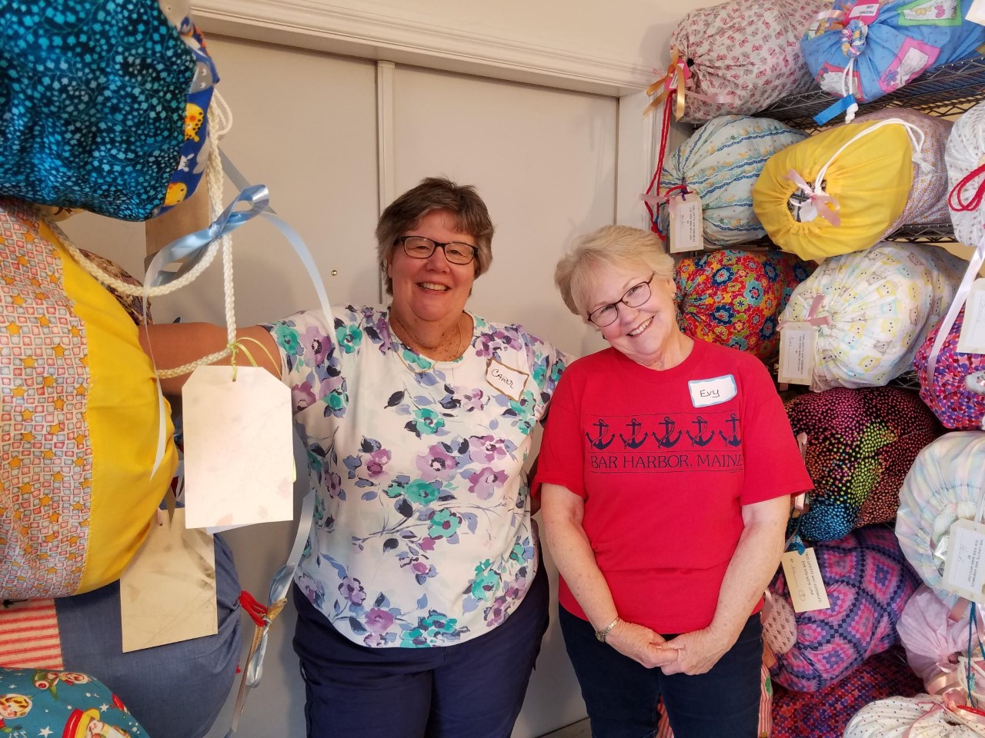
To learn more about Babies in Need or donate to support this vital ministry, please visit our website at www.babiesinneed.org.
We have a new mailing address:
All Saints / Babies in Need
P.O. Box 1441
Vancouver, WA 98668
and a new check-writing format:
Pay to the order of: All Saints Episcopal Church
Memo Line: Babies in Need
Thank you!
Kitty Ash, Executive Director
Mona Pocha, Associate Director
Pat Stephens, Secretary/Treasurer

